

**OBJECT ORIENTED PROGRAMMING(OOP)**

**SECTION 1**

**LAB ASSIGNMENT 7**

**DR.SAMRY @ MOHD.SHAMRIE SAININ**

**STUDENT NAME :** ANIZA ALIANA BINTI CHE JANI

**MATRIC NUMBER :** BI19110059

1. Add Menu Bar at the top with menu ‘Load Data’ to read from file and view in the output text area. Menu ‘Exit’ to show ‘showConfirmDialog’ and exit the application if user select ‘yes’ in the dialog.

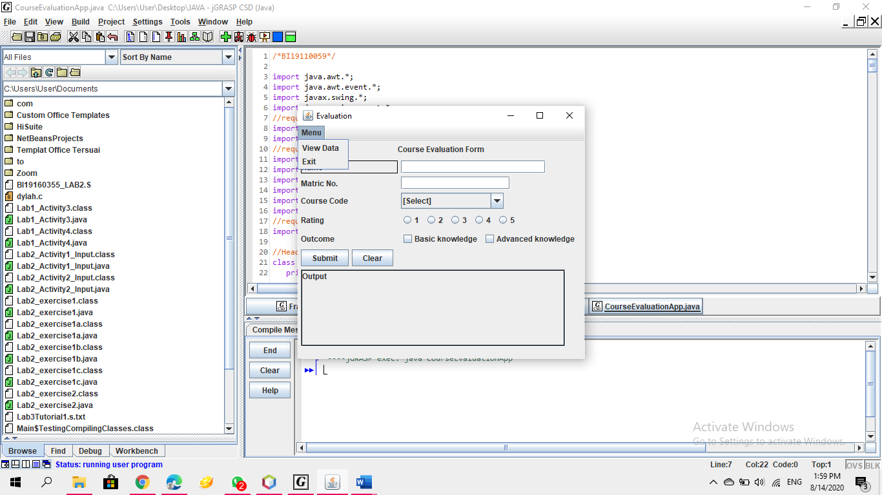

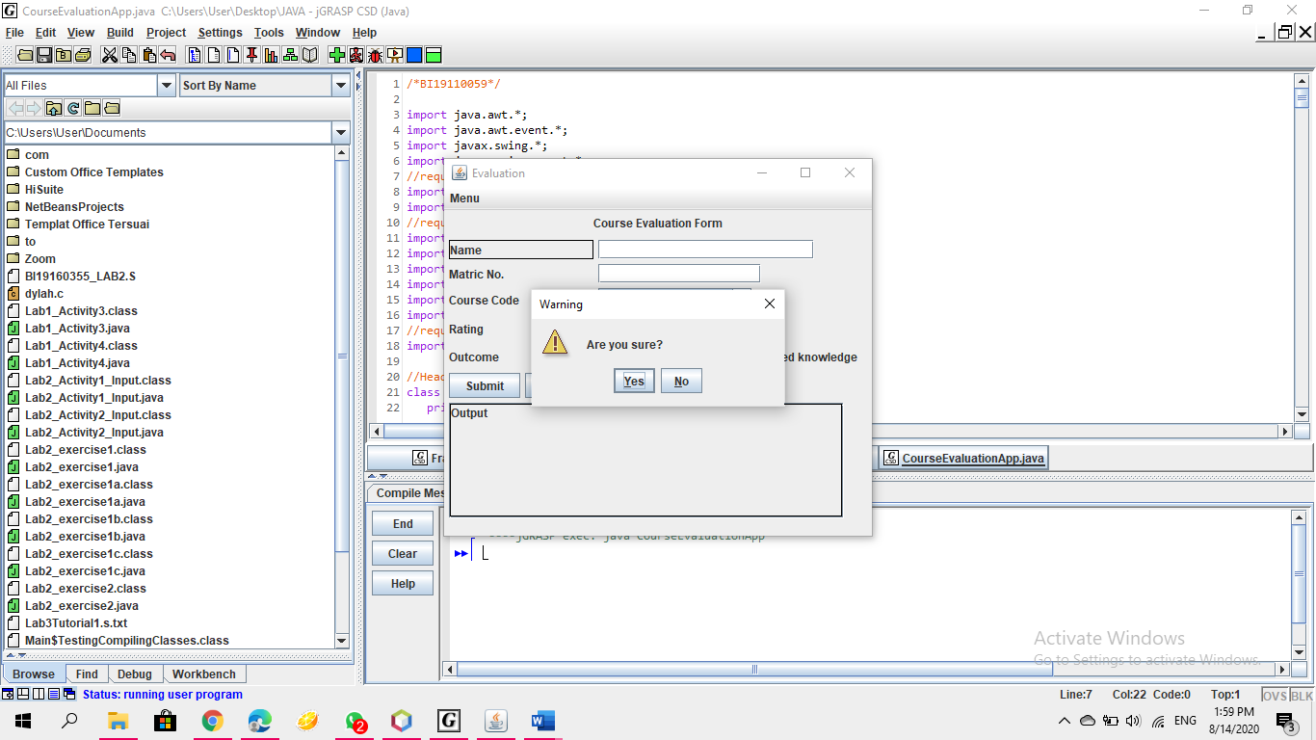

1. Input validation from all input to check if user empty field or selections when user click ‘Submit’ button.

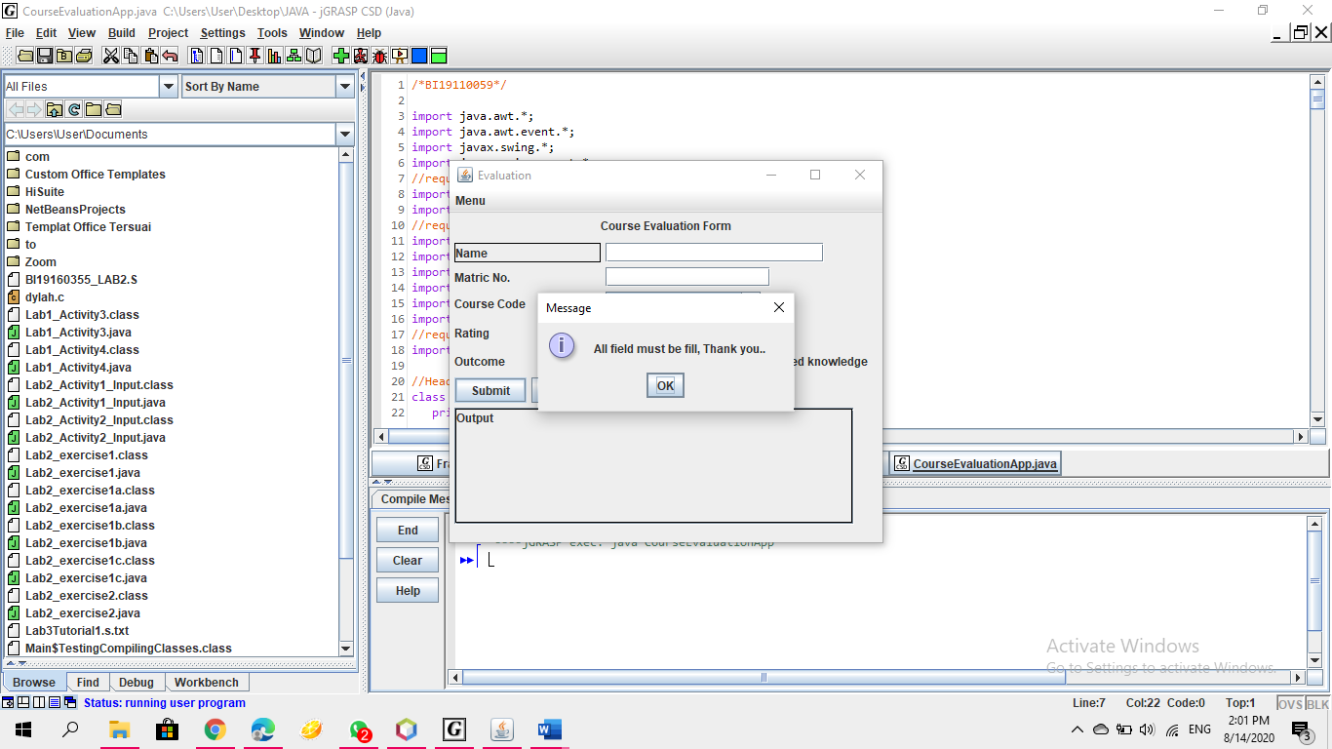

1. Save (add) the data into a text file with dialog notification (e.g. showMessageDialog) whether input is successfully saved

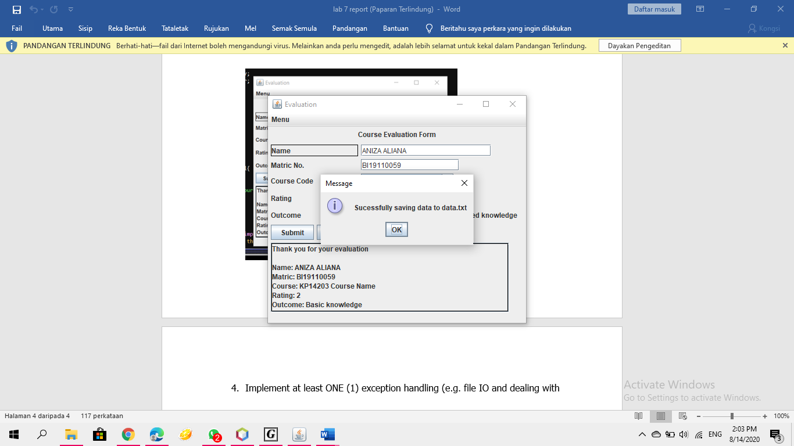

1. Implement at least ONE (1) exception handling (e.g. file IO and dealing with empty input field.

